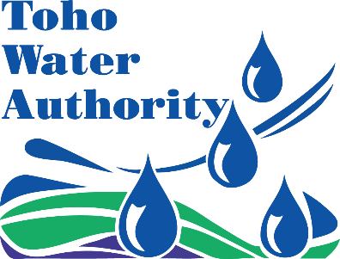
FOR IMMEDIATE RELEASE
January 8, 2026

Once service is restored, a precautionary boil water advisory will be in effect for customers on Toucan Court
Kissimmee, Florida -Toho Water Authority (Toho) is announcing that once service is restored, a precautionary boil water advisory will be in effect for customers located between 2400 – 2455 Toucan Court.
This is due to a contractor caused water line break in the area. Service is expected to be restored by 5 p.m. Schedules may change due to weather or unforeseen circumstances. The precautionary boil water advisory will be in effect until lifted by Toho.
As a precautionary measure, customers are advised to boil their water for one minute prior to consumption (drinking, cooking, making ice, brushing teeth or washing dishes). As an alternative, bottled water may be used. Water used for laundry or bathing/showering does not need to be boiled.
Once service is restored, a two-day minimum of regulatory testing is required to make sure the water meets drinking water standards. An update will be provided by Saturday, January 10, 2026.

For more information, contact Toho’s customer service at 407-957-7344 or visit our News & Alerts section on tohowater.com.

Use the interactive map
Enter your address in the interactive map to see if you’re in the advisory area. Due to circumstances outside of Toho’s control, the map may not reflect real-life conditions. Click here for interactive advisory map.

###
Toho Water Authority (Toho) is the largest provider of water, wastewater and reclaimed water services in Osceola County. Formed in 2003 by a special act by the Florida Legislature, it currently serves over 160,000 customers in St. Cloud, Kissimmee, Poinciana and unincorporated areas of Osceola Polk and Orange counties.

